

Press Release

Thessaloniki, 28.4.2025

Dr. Evangelos Bekiaris assumes the duties of new President of CERTH

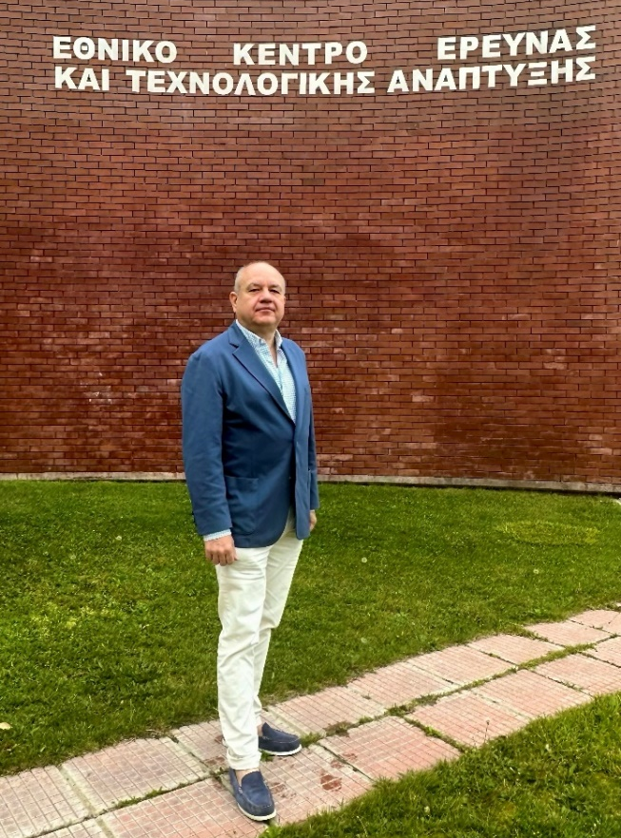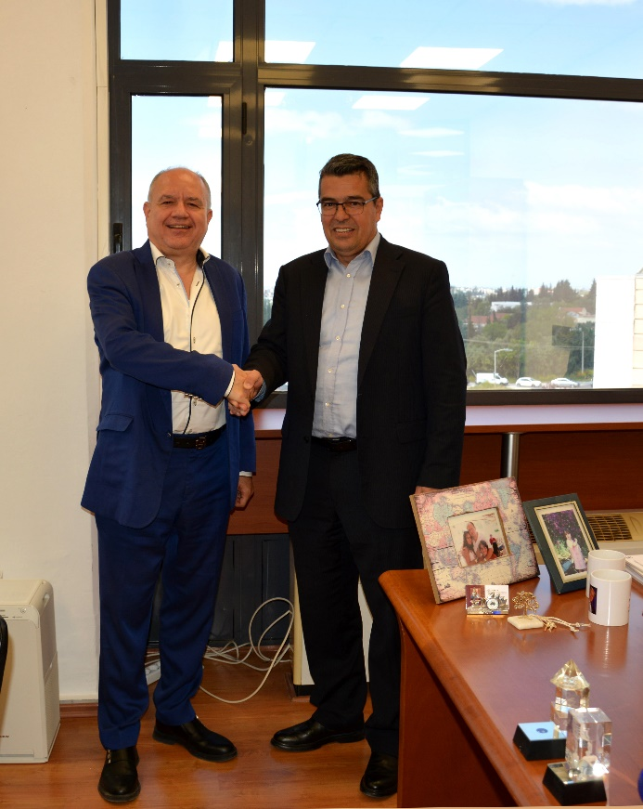
Picture 1: Dr. Evangelos Bekiaris assumed the duties of Chairman of the Board of Directors and Director of the Central Directorate of the Centre for Research and Technology Hellas (CERTH), on Friday 25 April 2025.
Picture 2: With a sense of responsibility and in an atmosphere of respect and mutual commitment to strengthening the mission of CERTH and shaping a strong innovation ecosystem, the handover of duties from the outgoing Chairman Dr. Tzovaras to Vice President Dr. Bekiaris took place.

The Mechanical Engineer from the National Technical University of Athens (NTUA), distinguished researcher in the field of Sustainable Mobility and Transport has taken over the duties of the position of Chairman of the Board of Directors of the Centre for Research and Technology Hellas (CERTH).

Election Process and Assumption of Duties
Dr. Evangelos Bekiaris assumed the duties of Chairman of the Board of Directors and Director of the Central Directorate of the Centre for Research and Technology Hellas (CERTH), on Friday 25 April 2025.
Dr. Bekiaris was elected to this position by an independent Evaluation Committee of seven distinguished scientists and academics from Greece and abroad. The committee was appointed by the National Council for Research, Technology and Innovation (NCRI) of the General Secretariat for Research and Innovation (GSRI) of the Greek Ministry of Development.

Strategic Priorities and Vision
Dr. Bekiaris’ vision for CERTH encompasses the preservation and continuous advancement of its scientific excellence across all areas of its endeavors alongside its commitment to fostering a sustainable future by delivering innovative solutions that benefit both society and the economy.
“It is both an honor and a profound responsibility for me to assume this position. In close collaboration with the dedicated team of CERTH I will make every effort to ensure that our Research Centre continues to grow and provide sustainable solutions to the critical challenges of our times. In a world that is constantly evolving, investing in research stands as a pivotal factor in addressing pressing issues such as the environmental crisis, the digital transition and challenges related to future mobility, health and nutrition. At the same time, my foremost priority is to maximize technology transfer through increased number of patents and spin-off companies and to drive the Centre’s development through targeted social initiatives. Furthermore, I aim to establish CERTH as one of the country’s leading employers”.
The exact title assigned to Dr Bekiaris is the Director of Central Directorate and Chairman of the Board of Directors of CERTH.
Scientific Career and Distinctions
Dr. E. Bekiaris, a Mechanical Engineer from NTUA, is a distinguished researcher in the field of Sustainable Mobility and Transport. Since 2001, he has been an elected researcher at the Hellenic Institute of Transport (HIT) of the Centre for Research and Technology Hellas (CERTH). He served as the Director of HIT from 2016 to 2024, completing two terms, and simultaneously held the position of Vice President of CERTH from 2021 to 2024. Since 1992 he has participated in 113 research projects, in 42 of which at the role of Coordinator.

He has been serving as Greece’s National Representative in the European Partnership of Cooperative, Connected & Automated Mobility (CCAM) since 2022, and since 2024, he is also an elected member of its Executive Board. Since 2019, he has been representing Greece in the "Climate-Neutral and Smart Cities" Initiative under the Horizon Europe (HE) Programme, while also presiding over the European Rail Research Network of Excellence (EURNEX).

In the past (2019-2023), he has been a member of the National Council for Research, Technology, and Innovation (NCRT), as well as Greece’s National Representative in the Horizon 2020 Transport Programme Committee (2014-2020).

Furthermore, he has served as President of the Hellenic Institute of Electric Vehicles (HELIEV) from 2021 to 2024, President of the European Transport Research Alliance (ETRA) in 2021, President of the European Conference of Transport Research Institutes (ECTRI) from 2019 to 2023, President of the European Associations FERSI (Road Safety, 2008-2011) and HUMANIST (on Human Factors in Transport, 2012-2015).

CERTH: A Hub of Research and Innovation

- 25 years of research and challenges
CERTH commemorates 25 years since its official establishment in 2000, reflecting on a journey marked by groundbreaking research, formidable challenges and technological innovations.
- Annual turnover €69,4 M€ - only 7,3% of which from Institutional State Funding
In 2024 CERTH generated a turnover of 69,4 M€, derived from bilateral industrial research contracts (11,4%), competitive European and national research grants (81,3%) and institutional state funding (7,3%).
- 1600 employees - associates
Today, CERTH employs over 1600 highly qualified persons in seven regions and nine cities across the country.
- Focusing on innovation
CERTH puts a strong emphasis on innovation, as evidenced by, -among other -, the establishment of bilateral contracts with industry, while the exploitation of its innovative outcomes of high technological readiness has resulted in the creation of 23 spin-off companies with significant economic activity, including attracting funding from investment funds.
- Top Research Centre in Greece and Europe
CERTH currently holds the top position among distinguished Greek research organizations and ranks 12th among European ones (data as of March 2025) in terms of attracting funding from competitive research grants. Notably, the CERTH was ranked among the top five EU research organizations in terms of attracting competitive funding in the field of Artificial Intelligence (AI) between 2021-2023.
- CERTH 2.0: The largest and most important development project under construction
The largest development project currently underway at CERTH is CERTH 2.0 – Research Excellence for Society and Economy. This ambitious initiative, supported by funding from the European Investment Bank (EIB) and the National Recovery & Resilience Fund (33,87M€), aims to upgrade and expand the Centre's cutting-edge research and development (R&D) infrastructure.

Contact information
-Amalia Drosou, journalist | Extroversion Department CERTH | Τηλ.: 2310 498214 Ι e-mail: amelidr@certh.gr

